**DIS-AM,C- Maya Jaguar God L**

**God L** of the [Schellhas-Zimmermann-Taube](https://en.wikipedia.org/w/index.php?title=Schellhas-Zimmermann-Taube&action=edit&redlink=1) classification of codical gods is one of the major pre-Spanish [Maya deities](https://en.wikipedia.org/wiki/Maya_deities), specifically associated with trade.

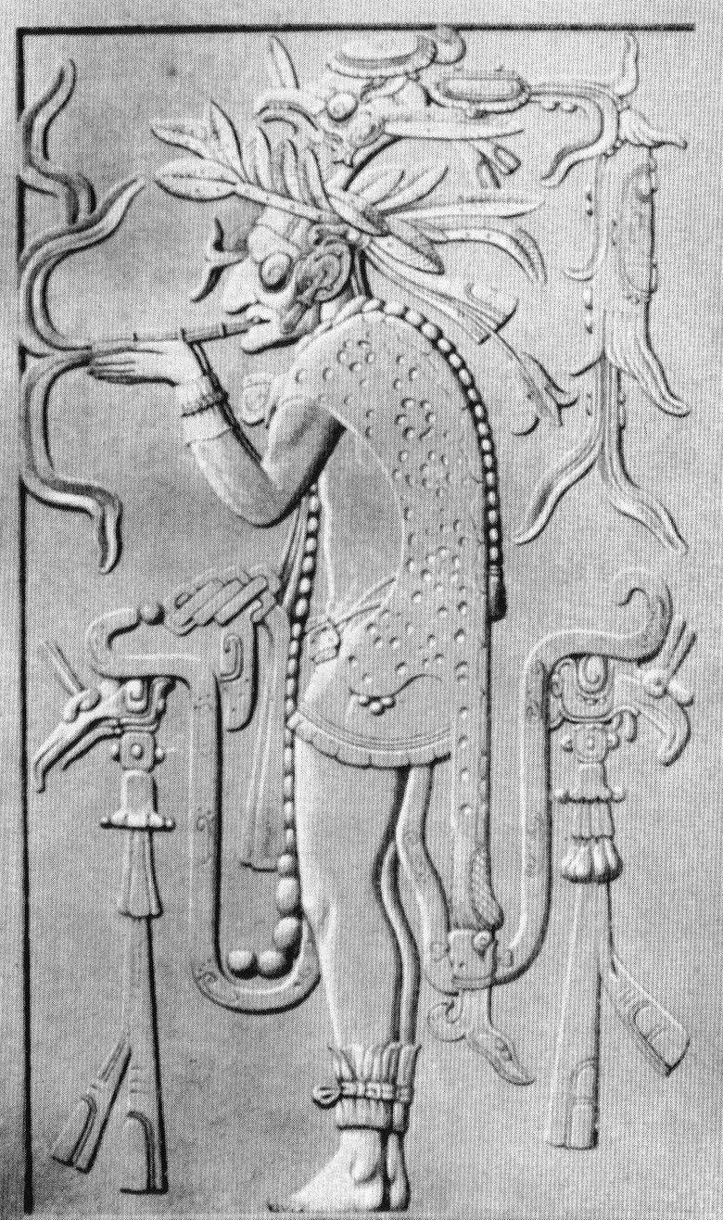

Reproduction of a Maya priest smoking from the Temple at Palenque, Mexico.

Characterized by high age, he is one of the [Mam](https://en.wikipedia.org/wiki/Mam_(Maya_mythology)) ('Grandfather') deities. More specifically, he evinces jaguar traits (particularly the ear), a broad feathery hat topped by an owl, and a jaguar mantle or a cape with a pattern somewhat resembling that of an armadillo shell. The best-known monumental representation is on a doorjamb of the inner sanctuary of Palenque's Temple of the Cross.

### Shamanism

The cigar which, more often than not, is smoked by god L suggests a shaman. The owl on the hat points a connection to the underworld and night, and recalls the Nahua term for sorcerer, *tlacatecolotl* 'Man-Owl'. The jaguar is also a a reference to night and the underworld.

### War

God L's jaguar and owl (*kuy*) attributes point to sorcery, violence, and warfare,[[2]](https://en.wikipedia.org/wiki/God_L" \l "cite_note-2) qualities that may be related to his Postclassic role as a personification of Venus rising from the underworld, and throwing spears at his victims (Dresden Codex). God L's connection to warfare is also suggested by the decapitation of a bound prisoner, perhaps a captive king, in front of god L's jaguar palace (Princeton vase). On the central relief of the Palenque Temple of the Sun - a war temple - god L, together with one of the other [Maya jaguar gods](https://en.wikipedia.org/wiki/Maya_jaguar_gods) (viz. the Jaguar God of Terrestrial Fire), supports an emblem consisting of the sacred shield and lances of the Palenque kings. His submissive posture suggests he now represents a defeated enemy chief.